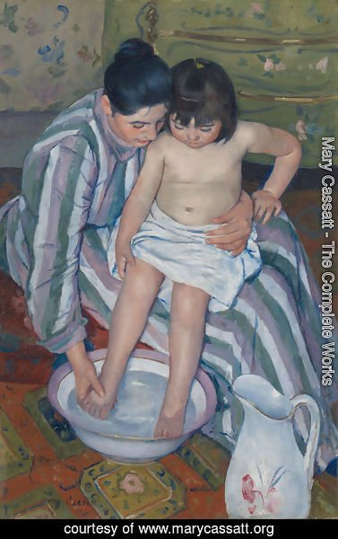 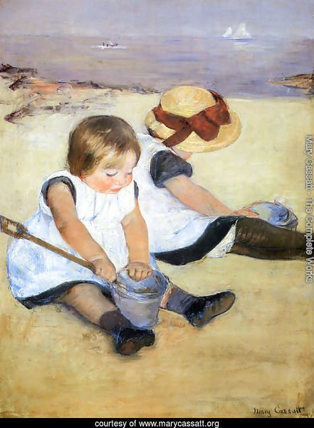

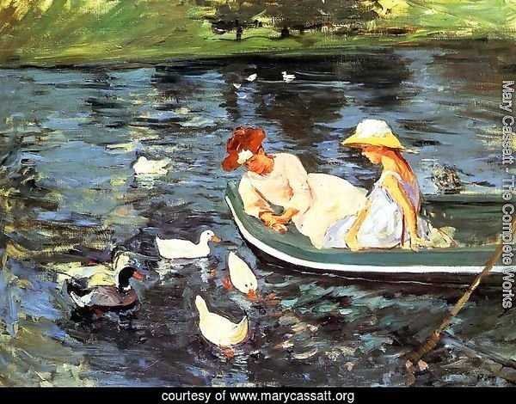 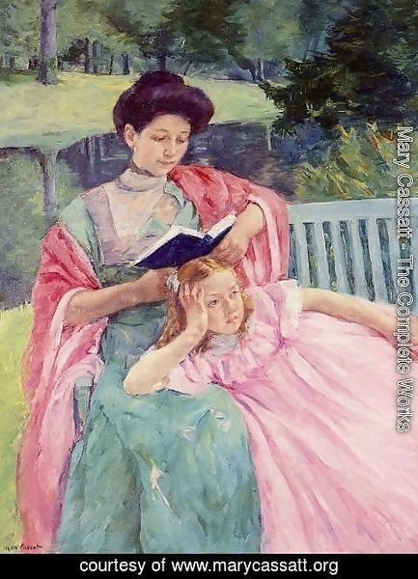

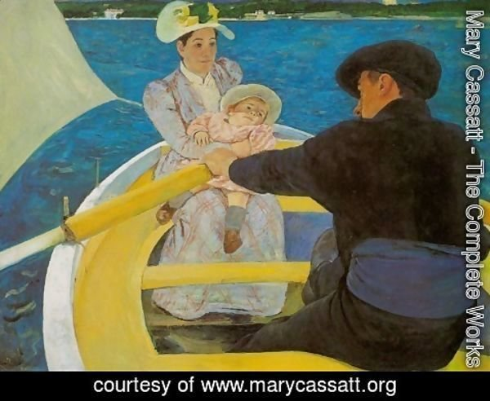

|  |  |  |
| --- | --- | --- |
| Summertime 2 | Children playing on the Beach |  |
| Auguste reading to her daughter | The Boating Party | The Child’s Bath (1893) |

Describe the paintings so that your classmates can guess which one you are describing.

**The Child’s Bath**

[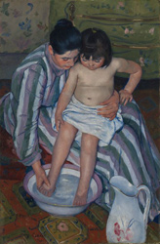](http://www.artic.edu/aic/collections/exhibitions/Impressionism/artwork/111442)

**Mary Cassatt   
American, 1844–1926   
*The Child’s Bath*   
1893**

Oil on canvas   
100.3 x 66.1 cm (39 1/2 x 26 in. )   
Signed lower left: "Mary Cassatt"   
Robert A. Waller Fund, 1910.2

Mary Cassatt was the only American to exhibit with the original [Impressionist](http://www.artic.edu/aic/collections/exhibitions/Impressionism/Glossary#Impressionism) group. Like her friend [Degas](http://www.artic.edu/aic/collections/exhibitions/Impressionism/Degas), she was a highly skilled [draftsman](http://www.artic.edu/aic/collections/exhibitions/Impressionism/Glossary#draftsman) who preferred unposed, [asymmetrical](http://www.artic.edu/aic/collections/exhibitions/Impressionism/Glossary#asymmetrical) [compositions](http://www.artic.edu/aic/collections/exhibitions/Impressionism/Glossary#composition). In *The Child's Bath*, the circular shapes of the figures’ heads, the basin, and the pitcher as well as the striped pattern of the woman’s dress animate the portrait of a woman bathing a child. Cassatt’s unusual vantage point (from above) and her choice of a female subject show her interest in Japanese [woodblock prints](http://www.artic.edu/aic/collections/exhibitions/Impressionism/Glossary#woodblock), which had become extremely popular in France at the time.

The theme of women caring for children appeared frequently in Cassatt’s art during and after the 1880s. In rendering this subject, the artist relied on keen observation rather than idealization, yet still portraying great intimacy. The woman’s gestures—one firm hand securing the child in her lap, the other gently caressing its small foot—are both natural and emblematic, communicating her tender concern for the child’s well-being. The two figures gaze in the same direction, looking together at their paired reflection in the basin of water.

The many paintings, pastels, and prints in which Cassatt depicted children being bathed, dressed, read to, held, or nursed reflect the most advanced 19th-century ideas about raising children. After 1870, French scientists and physicians encouraged mothers (instead of [wet-nurses](http://www.artic.edu/aic/collections/exhibitions/Impressionism/Glossary#wet-nurse) and nannies) to care for their children and suggested modern approaches to health and personal hygiene, including regular bathing. In the face of several [cholera](http://www.artic.edu/aic/collections/exhibitions/Impressionism/Glossary#cholera) epidemics in the mid-1880s, bathing was encouraged not only as a remedy for body odors but also as a preventative measure against disease.

A contemporary of Cassatt admired her paintings of mothers and children:

“It would seem, however, that Miss Cassatt has found her true bent in her recent pictures of children and in the delineation of happy maternity. Here she has caught with great fidelity the beauty of child life and the dignity of motherhood, fitting subjects for the artist’s brush, ennobling material for intellectual investigation. These she has portrayed with delicacy, refinement, and sentiment. Her technic [sic] appeals equally to the layman and the artist, and her color has all the tenderness and charm that accompanies so engaging a motif.”

Arthur Hoeber, “The Century’s American Artist Series: Mary Cassatt,” Century Magazine, no. 57 (March 1899); reprinted in Sarah Burns and John Davis, American Art to 1900: A Documentary History (Berkeley, CA: University of California Press, 2009), pp. 837-8.

Steven Buettner notes the significance of the motherhood theme in the late nineteenth century:

“It was during this time, during the Third Republic, that the subject of Modern Motherhood received its first thoroughgoing, unsentimental treatment by two artists working in France: Berthe Morisot and Mary Cassatt. These painters began to examine, tentatively at first, the psychological relationship between mother and child. From the time of the Renaissance, women artists who treated this subject purged it first of its religious and then of its historical, mythological, and sentimental overtones. Traditional compositions, however, were often preserved.”

Stewart Buettner, “Images of Modern Motherhood in the Art of Morisot, Cassatt, Modersohn-Becker, Kollwitz,” Woman’s Art Journal, vol. 7, no. 2 (Autumn 1986 - Winter 1987): 15.

Griselda Pollock offers insight into Cassatt’s compositional choices in The Child’s Bath :

“In The Child’s Bath… Cassatt again used contrasts of patterned areas to enliven and construct the painted surface against which the plain towel and the naked body of the child achieve pictorial prominence… in the painting Cassatt employed a more acute angle of vision, viewing the scene from above so that the space depicted is tilted sharply upwards towards the plane of the canvas. Yet the solidity of the forms, the opposing diagonals of the figures and the contrasts of texture deny this purely decorative tendency… the effect of the angle of vision is to concentrate attention on the two figures, whose gaze reinforces the direction of the spectator’s look toward the activity in which they are both engaged. By this means the image of mother and child is pruned of many of its traditional emotional associations. Thus in contrast to Cassatt’s previous work, in which formal devices were manipulated to engage interest in the unexpected symbolic meanings of a mundane act, a very structured composition is deployed here in order to emphasize the actions of rather than the relationship between mother and child.”