montagne | lac | pieu
pierre | forêt | oeuf

montagne | lac | pieu
pierre | forêt | oeuf

montagne | lac | pieu
pierre | forêt | oeuf

montagne | lac | pieu
pierre | forêt | oeuf

montagne | lac | pieu
pierre | forêt | oeuf

montagne | lac | pieu
pierre | forêt | oeuf

☺ 😐 ☹

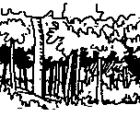 |  | 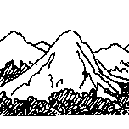
forêt |  | montagne |  | lac

 |  | 
pieu |  | oeuf |  | pierre

a | c | e | f | g | i | l | m | n | o | p | r | t | u
A | C | E | F | G | I | L | M | N | O | P | R | T | U

