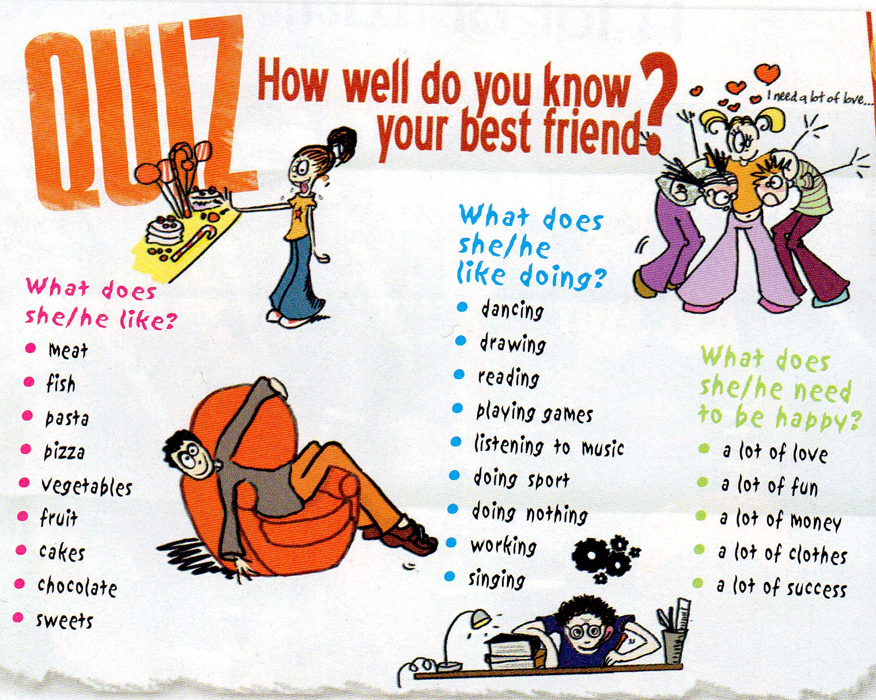
Book 2 Lesson 3
- Complete the summary :
-What does Angie like ?
Angie loves ………………………….. and…………………………
-What does she like doing ?
She likes ……………………………., ………………….…………………..
and …………………………..……………….
-What does she need to be happy ?
She needs …………………………………. and ………………..
………………….

- What about killian ?
-What ………………….….. Killian ……………..…………… ?
…………………………………………………………………………………………………………………………………………………….
-……………………………………………………………………………………………………………………………………………………?
……………………………………………………………………………………………………………………………………………………….
-…………………………………………………………………………………………………………………………………………………….. ?
………………………………………………………………………….…………………………………………………………………………….

