**Travel advices**

Task 1: Read the following travel advices by Brian and Liza. Write down the **positive** and the **negative elements** concerning these advices. Write down **your own opinion**. **Would you like to visit these places or not and why?** You have to **pick one advice** and **present it** as well as your **personal opinion** on it **to the class**. In the end, you have to **write an own travel advice with negative and positive elements as well as your personal opinion**.

[The poor district of Cazenga, in western Luanda Copyright: DW/Renate Krieger
](http://www.dw.de/poverty-mars-angolas-petroleum-paradise/a-16532413)

**First travel advice: Luanda, Angola**

Brian: Luanda is the capital and largest city of Angola in Southern Africa. There are a lot of foreign investments in diamond mines and oil agriculture and the economy is getting better and better. The mixture of Portuguese and different African cultures is very appealing. The spicy food with chicken, corn, fishes, papayas, Port wine and seafood is delicious. The famous Belas Shopping Center is Africa’s most modern mall.

Liza: After a long civil war, many buildings in Luanda are still destroyed. There are a lot of epidemics in Angola. The country has incredible ressources but large parts of its population are very poor. Don’t get out of the capital because there are still millions of landmines placed around it. Luanda is though the most expensive city in the world for expatriats because of many imported products. A bottle of Coca-Cola costs $5.69, a burger at a fast food restaurant is worth $20.38 and you have to pay $405 for a monthly gym membership.

Negative elements:

________________________________________________________________________________________________________________________________________________________________________________________________________________________________________________________________________________________________________________________________________________________________________

Positive elements:

________________________________________________________________________________________________________________________________________________________________________________________________________________________________________________________________________________________________________________________________________________________________________

Your opinion:

________________________________________________________________________________________________________________________________________________________________________________________________________________________________________________________________________________________________________________________________________________________________________

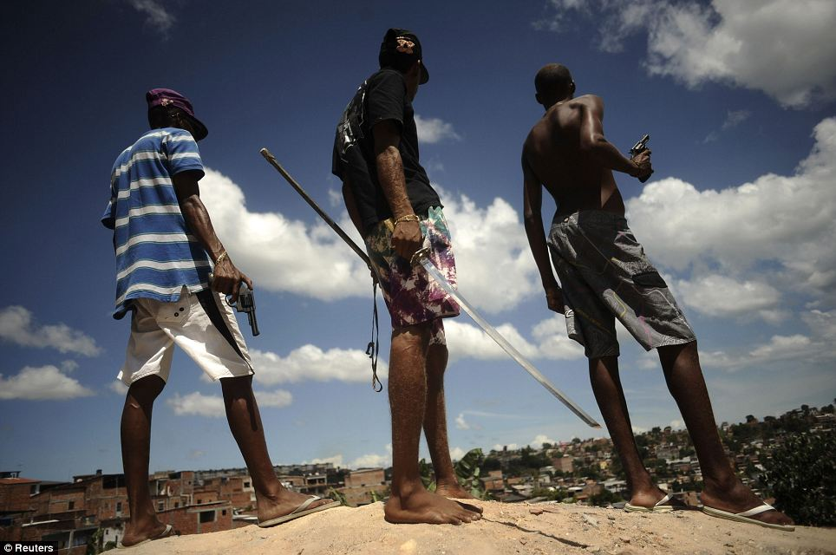

**Second travel advice: Salvador, Brazil**

Liza: Salvador is considered as one of the birthplaces of Brazilian culture. The city is known for the biggest Carnival in the world. It has many big beaches where you can go biking, hiking and surfing. The city’s Old Town is an enjoyable World Heritage site.

Brian: The dense slums of the city are ruled by brutal gangsters. Abductions, drug dealing, muggings, pickpocketing, robberies are very frequent there. There are also many cases of corruption and racism. There are also a lot of traffic victims.

Negative elements:

________________________________________________________________________________________________________________________________________________________________________________________________________________________________________________________________________________________________________________________________________________________________________

Positive elements:

________________________________________________________________________________________________________________________________________________________________________________________________________________________________________________________________________________________________________________________________________________________________________

Your opinion:

________________________________________________________________________________________________________________________________________________________________________________________________________________________________________________________________________________________________________________________________________________________________________

[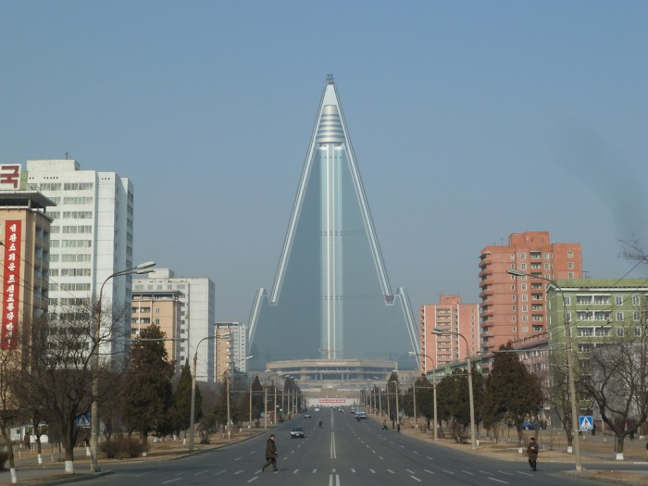](http://goista.com/wp-content/uploads/2014/01/Pyongyang-The-North-Koreans-Showcase-City.jpg)

**Third travel advice: Pyongyang, Democratic People’s Republic of Korea**

Brian: Pyongyang is a city filled with amazing monuments such as the impressive Juche Tower, the giant bronze statues at Mansudae and the biggest stadium in the world which is the Rungnado May Day Stadium. It’s a very clean city and there is almost no traffic. There is almost no criminality as well.

Liza: Officially, North Korea is still at war with South Korea and that’s why there are always a lot of soldiers around which can give you a strange feeling. If you visit Pyongyang, you are always accompanied by a tourist guide and you can’t walk around wherever you want to go. If you do anything that could offend the government such as approaching people in the streets, taking pictures of other things than monuments or talking about politics, you can easily get arrested and deported.

Negative elements:

________________________________________________________________________________________________________________________________________________________________________________________________________________________________________________________________________________________________________________________________________________________________________

Positive elements:

________________________________________________________________________________________________________________________________________________________________________________________________________________________________________________________________________________________________________________________________________________________________________

Your opinion:

________________________________________________________________________________________________________________________________________________________________________________________________________________________________________________________________________________________________________________________________________________________________________

[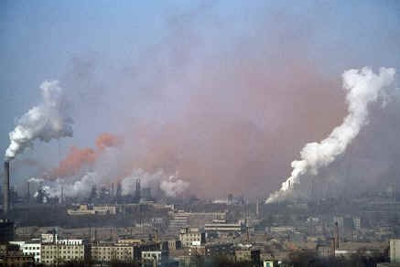](http://www.dotting.me/en/images/photos/209/ksry3plp.jpg)

**Fourth travel advice: Sukinda, India**

Liza: There are a lot of interesting things to visit around Sukinda such as the city of Cuttack with the Barabati Fort, the Satkiosa Tiger reserve or the 400-hectare Nandankanan Zoological Park. The Bay of Bengali s not far away either where you can have some fun at the beaches at very low prices. Public transport is above average standard. There are a lot of educated scientists and people speak English very well.

Brian: This region accounts for about 98% of India’s proved chromite reserves. Around twelve mines operate in this area without proper environmental controls. These mines are a major health hazard, pollute air, earth and water and menace life expectancy of around 2.5 million people.

Negative elements:

________________________________________________________________________________________________________________________________________________________________________________________________________________________________________________________________________________________________________________________________________________________________________

Positive elements:

________________________________________________________________________________________________________________________________________________________________________________________________________________________________________________________________________________________________________________________________________________________________________

Your opinion:

________________________________________________________________________________________________________________________________________________________________________________________________________________________________________________________________________________________________________________________________________________________________________

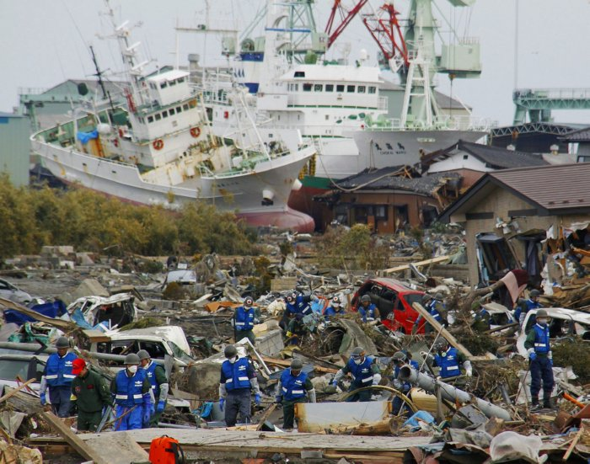

**Fifth travel advice: Miyako, Japan**

Brian: There are many amazing landscapes around this city such as the Cape of Dodo with bits lighthouse. The impressive Jodogahama beach with the Rocks of Rosoku and Sano offers some nice hiking trails. The region is known for many excellent restaurants where you can eat rare sushi such as the blowfish. Prices are a lot less expensive than in Japan’s bigger cities and people are friendly to foreigners. Occasionally, there are some interesting hip-hop and RnB events in Miyako.

Liza: Some important parts of the city have been devastated by a tsunami caused by the Tohoku earthquake in 2011. More than 400 people died, many people got evacuated and the most important infrastructures got destroyed. The area is still highly polluted by radioactive material.

Negative elements:

________________________________________________________________________________________________________________________________________________________________________________________________________________________________________________________________________________________________________________________________________________________________________

Positive elements:

________________________________________________________________________________________________________________________________________________________________________________________________________________________________________________________________________________________________________________________________________________________________________

Your opinion:

________________________________________________________________________________________________________________________________________________________________________________________________________________________________________________________________________________________________________________________________________________________________________

[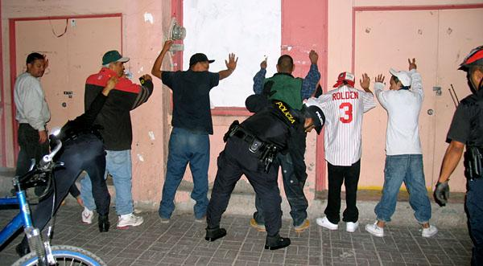](http://www.funnymalaysia.net/wp-content/uploads/2013/06/ciudad-huarez-mexico-crime.jpg)

**Sixth travel advice: Ciudad Juarez, Mexico**

Liza: This city is situated in a natural desert. You will be impressed by the local cowboy culture. There are a few great distilleries you can visit. You can also attend a bullfight at the Plaza de Toros. You absolutely have to visit the Samalayuca Dune Fields where you can practice sandboarding. There are also parks where you can go ziplining and paintballing.

Brian: The region’s rapid desertification is a big problem. Another issue is the ongoing MNexican Drug War. There are violent conflicts between different drug cartels, local police officers and the military. If you get into public shootouts, look for cover in alleyways, under cars, in garbage cans or copy the behavior of the locals as they are used to those events. Violence towards women has also dramatically increased in this region over the past twenty years. The city is also known for underage drinking and violent bar brawls. Foreigners are often easy targets for street gangs.

Negative elements:

________________________________________________________________________________________________________________________________________________________________________________________________________________________________________________________________________________________________________________________________________________________________________

Positive elements:

________________________________________________________________________________________________________________________________________________________________________________________________________________________________________________________________________________________________________________________________________________________________________

Your opinion:

________________________________________________________________________________________________________________________________________________________________________________________________________________________________________________________________________________________________________________________________________________________________________

[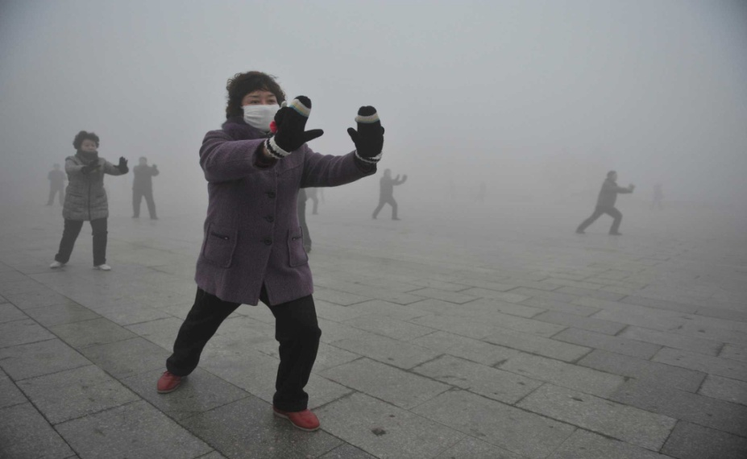](http://guardianlv.com/wp-content/uploads/2014/01/Beijing-Sunrise-is-Virtual.jpg)

**Seventh travel advice: Beijing, People’s Republic of China**

Brian: China’s capital is one of the most impressive cities in the world. Public transport is excellent and you can easily find good hotels and restaurants. You have to visit the historical Forbidden City, the world’s largest public square which is the legendary Tiananmen Square and the many sites of the Beijing 2008 Olympic Games. The Great Wall of China is only about one hour away from Beijing and one of the new seven Wonders of the World.

Liza: Beijing is also one of the dirtiest cities in the world due to an important smog problem that has become more and more important over the last years. Air pollution is caused by automobile exhaust, coal burning and dust storms from the Gobi desert. Many older people suffer from cardiovascular diseases or lung cancer. Other problems are pickpocketing and scams on tourists. The restricted internet access where Facebook, Twitter and YouTube are completely blocked may also confuse some visitors.

Negative elements:

________________________________________________________________________________________________________________________________________________________________________________________________________________________________________________________________________________________________________________________________________________________________________

Positive elements:

________________________________________________________________________________________________________________________________________________________________________________________________________________________________________________________________________________________________________________________________________________________________________

Your opinion:

________________________________________________________________________________________________________________________________________________________________________________________________________________________________________________________________________________________________________________________________________________________________________

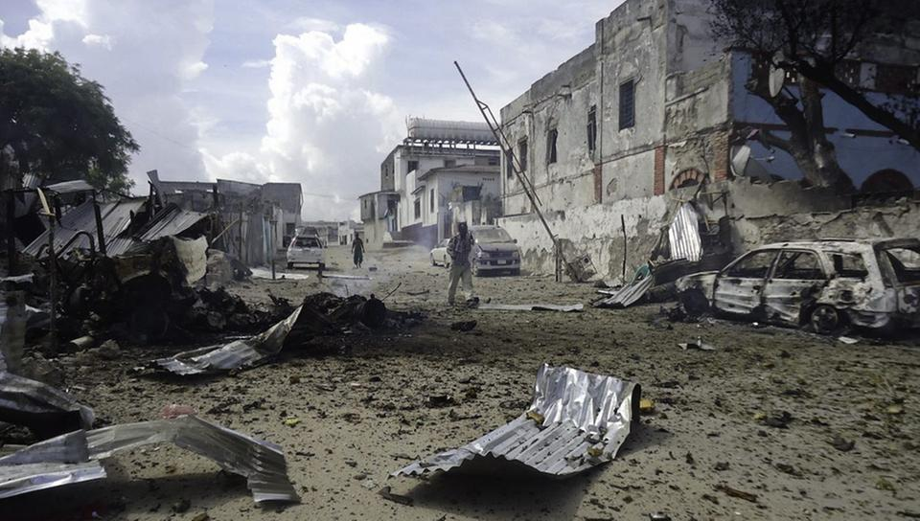

**Eighth travel advice: Mogadishu, Somalia**

Liza: Mogadishu is a colourful city close to impressive beaches and modern hotels on the Indian Ocean. The historical port and the large beaches are great for long walks. Weather conditions are very good. There are a lot of interesting places to visit such as the large Bakaara Market where you can find almost anything you can imagine.

Brian: Mogadishu is a once beautiful city ruined by a still ongoing civil war. Public transportation is practically non-existant. Health services are very limited and it’s difficult to get access to basic services such as water and electricity. There are a lot of thefts and violent crimes. Especially rich foreigners are targeted. You can’t walk around alone in the streets or stay in hotels without armed guards.

Negative elements:

________________________________________________________________________________________________________________________________________________________________________________________________________________________________________________________________________________________________________________________________________________________________________

Positive elements:

________________________________________________________________________________________________________________________________________________________________________________________________________________________________________________________________________________________________________________________________________________________________________

Your opinion:

________________________________________________________________________________________________________________________________________________________________________________________________________________________________________________________________________________________________________________________________________________________________________

[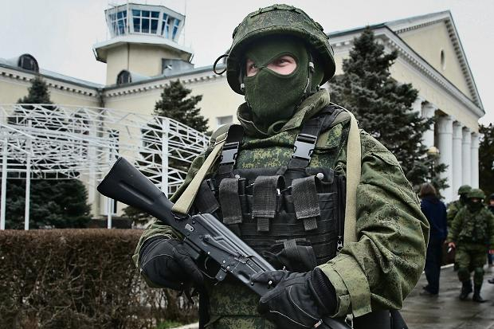](http://www.thetimes.co.uk/tto/news/world/europe/article4018940.ece#tab-4)

**Ninth travel advice: Simferopol, Ukraine**

Brian: Simferopol is close to the Black Sea where you can have a great holiday on the beach for a reasonable price. The city includes many galleries, museums and religious sites. The city is also known for exotic local food. You can visit the Crimean Astrophysical Observatory, go hiking in the nearby mountains, get on a guided tour on the longest trolleybus line in the world and visit the first Soviet radio telescope in the nearby Shkol’noe village.

Liza: Simferopol is shattered by a pro-Russian separatist movement supported by self-defense militias that attacked Ukrainian government buildings, military bases and important checkpoints. Ethnic minorities, journalists and tourists have also been attacked recently. The situation might easily escalate into a war zone.

Negative elements:

________________________________________________________________________________________________________________________________________________________________________________________________________________________________________________________________________________________________________________________________________________________________________

Positive elements:

________________________________________________________________________________________________________________________________________________________________________________________________________________________________________________________________________________________________________________________________________________________________________

Your opinion:

________________________________________________________________________________________________________________________________________________________________________________________________________________________________________________________________________________________________________________________________________________________________________

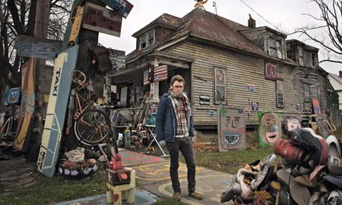

**Tenth travel advice: Detroit, United States of America**

Liza: Detroit has a series of impressive skyscrapers such as the Fisher Building, the Renaissance Center and the four RenCen Towers. The city offers a variety of museums and parks. Downtown Detroit is known for many famous bars, concert halls and restaurants. Many popular musicians that have made their first steps in this city such as Eminem, the Funk Brothers, Iggy Pop, the Jones Brothers or Ted Nugent. You can also find many professional and internationally known sports teams that are playing in the Major League Baseball, the National Football League and the National Hockey League. Detroit is close to many colourful Canadian cities such as Windsor and Lake Erie.

Brian: Detroit filed the largest municipal bankruptcy case in American history in 2013. The city has issues with abandoned buildings, elevated crime rates and electric power distribution. Many big companies such as General Motors had to shut down partially or even completely. The population has decreased from 1.85 million people in 1950 to 681,090 people in 2013.

Negative elements:

________________________________________________________________________________________________________________________________________________________________________________________________________________________________________________________________________________________________________________________________________________________________________

Positive elements:

________________________________________________________________________________________________________________________________________________________________________________________________________________________________________________________________________________________________________________________________________________________________________

Your opinion:

________________________________________________________________________________________________________________________________________________________________________________________________________________________________________________________________________________________________________________________________________________________________________

**Eleventh travel advice: ____________________________________________________**

Negative elements:

________________________________________________________________________________________________________________________________________________________________________________________________________________________________________________________________________________________________________________________________________________________________________

Positive elements:

________________________________________________________________________________________________________________________________________________________________________________________________________________________________________________________________________________________________________________________________________________________________________

Your opinion:

________________________________________________________________________________________________________________________________________________________________________________________________________________________________________________________________________________________________________________________________________________________________________