|  |  |  |  |  |
| --- | --- | --- | --- | --- |
|  |  |  |  |  |
|  |  |  |  |  |
|  |  |  |  |  |
|  |  |  |  |  |
|  |  |  |  |  |
|  |  |  |  |  |

|  |  |  |
| --- | --- | --- |
|  |  |  |
|  |  |  |
|  |  |  |
|  |  |  |

A imprimer plusieurs fois

|  |  |  |
| --- | --- | --- |
| 11 | 12 | 13 |
| 14 | 15 | 16 |
| 17 | 18 | 19 |
| 20 | 21 | 22 |

|  |  |  |
| --- | --- | --- |
| 23 | 24 | 25 |
| 26 | 27 | 28 |
| 29 | 30 | 31 |
| 32 | 33 | 34 |

|  |  |  |
| --- | --- | --- |
| 35 | 36 | 37 |
| 38 | 39 | 40 |
| 41 | 42 | 43 |
| 44 | 45 | 46 |

|  |  |  |
| --- | --- | --- |
| 47 | 48 | 49 |
| 50 | 51 | 52 |
| 53 | 54 | 55 |
| 56 | 57 | 58 |

|  |  |  |
| --- | --- | --- |
| 59 | 60 | 61 |
| 62 | 63 | 64 |
| 65 | 66 | 67 |
| 68 | 69 | 70 |

|  |  |  |
| --- | --- | --- |
| 71 | 72 | 73 |
| 74 | 75 | 76 |
| 77 | 78 | 79 |
| 80 | 81 | 82 |

|  |  |  |
| --- | --- | --- |
| 83 | 84 | 85 |
| 86 | 87 | 88 |
| 89 | 90 | 91 |
| 92 | 93 | 94 |



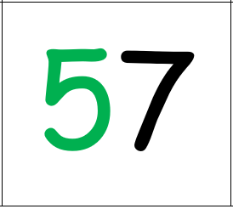

* *

* Decompositions additives *