English
4

Christmas
What is it ?
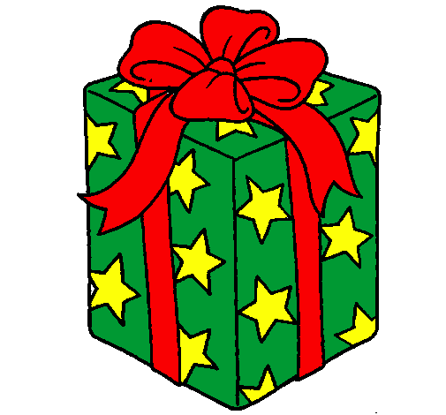  It is a present. | 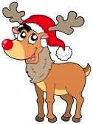  It is a reindeer. | 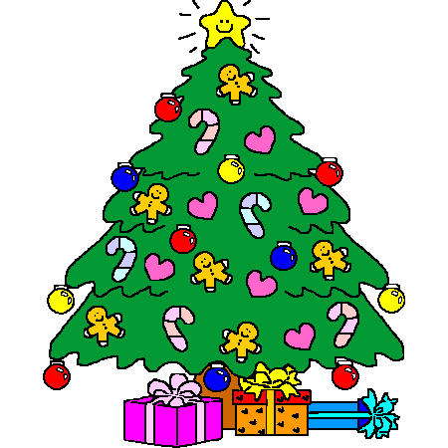  It is a Christmas tree. | 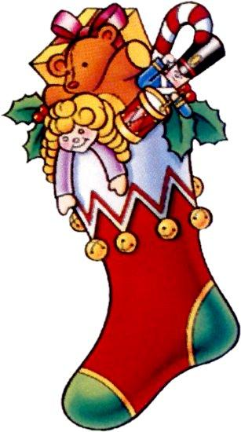  It is a stocking.
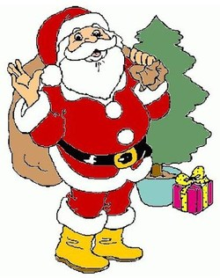  It is a Christmas father. | 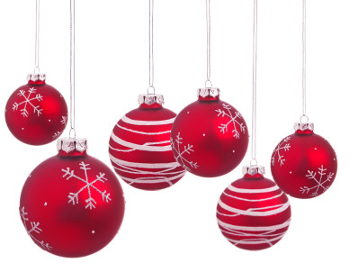  It is a bauble. | It is a snowflake. | 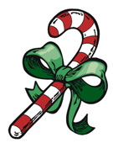  It is a candy cane.
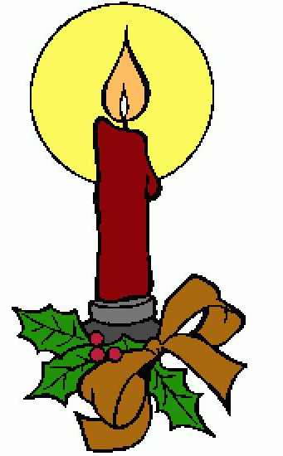  It is a candle. | 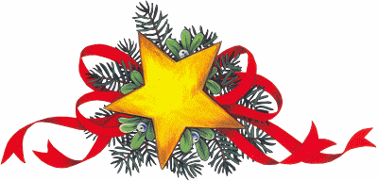  It is a star. | 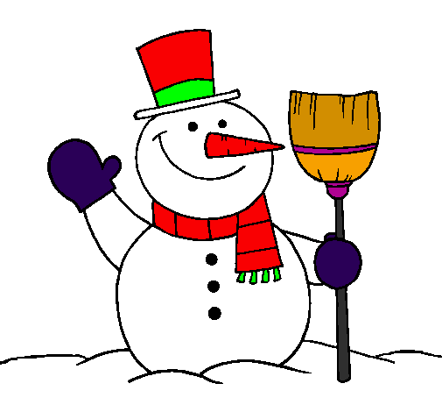  It is a snowman | 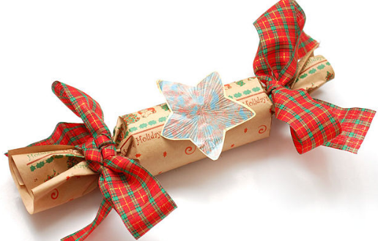  It is a cracker.
Merry Christmas and Happy New Year!

