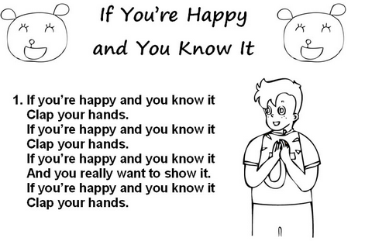

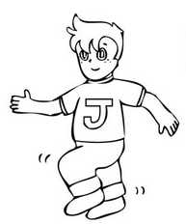
If you're happy and you know it
Stomp your feet (Stomp, Stomp)
If you're happy and you know it,
Stomp your feet (Stomp, Stomp)
If you're happy and you know it,
If you're happy and you know it,
If you're happy and you know it,
Stomp your feet (Stomp, Stomp)

Shake your head

Touch your back

Show your hair

Close your eyes

Slam fingers

Move your arms

Fold your legs…

