Écriture : écrire des mots en lettres majuscules, entre deux lignes

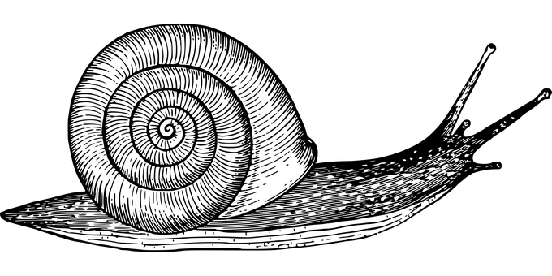

UN ESCARGOT

____________________________________________________

_.___________________________________________________

UN GENDARME

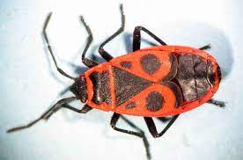

____________________________________________________

_.___________________________________________________



UNE COCCINELLE

____________________________________________________

_.___________________________________________________

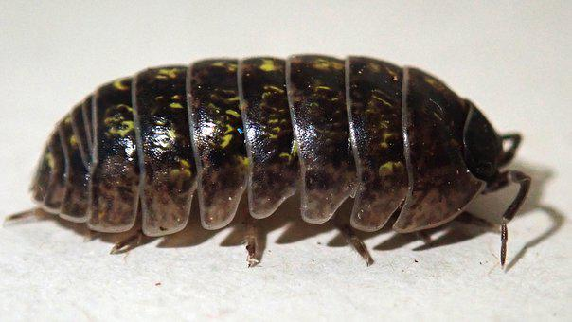

UN CLOPORTE

____________________________________________________

_.___________________________________________________