  Septembre

|  |  |  |
| --- | --- | --- |
| **L** | **2** | C’est la Rentrée !! |
| **M** | **3** |  |
| **M** | **4** |  |
| **J** | **5** |  |
| **V** | **6** |  |
| **S** | **7** |  |
| **D** | **8** |  |
| **L** | **9** |  |
| **M** | **10** |  |
| **M** | **11** |  |
| **J** | **12** |  |
| **V** | **13** |  |
| **S** | **14** |  |
| **D** | **15** |  |
| **L** | **16** |  |
| **M** | **17** |  |
| **M** | **18** |  |
| **J** | **19** |  |
| **V** | **20** |  |
| **S** | **21** |  |
| **D** | **22** | **AUTOMNE** |
| **L** | **23** |  |
| **M** | **24** |  |
| **M** | **25** |  |
| **J** | **26** |  |
| **V** | **27** |  |
| **S** | **28** |  |
| **D** | **29** |  |
| **L** | **30** |  |

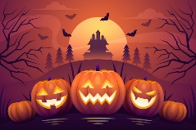Octobre

|  |  |  |
| --- | --- | --- |
| **M** | **1** |  |
| **M** | **2** |  |
| **J** | **3** |  |
| **V** | **4** |  |
| **S** | **5** |  |
| **D** | **6** |  |
| **L** | **7** |  |
| **M** | **8** |  |
| **M** | **9** |  |
| **J** | **10** |  |
| **V** | **11** |  |
| **S** | **12** |  |
| **D** | **13** |  |
| **L** | **14** | Image associÃ©e |
| **M** | **15** | Image associÃ©e |
| **M** | **16** | Image associÃ©e |
| **J** | **17** |  |
| **V** | **18** |  |
| **S** | **19** |  |
| **D** | **20** |  |
| **L** | **21** |  |
| **M** | **22** |  |
| **M** | **23** |  |
| **J** | **24** |  |
| **V** | **25** |  |
| **S** | **26** |  |
| **D** | **27** |  |
| **L** | **28** |  |
| **M** | **29** |  |
| **M** | **30** |  |
| **J** | **31** | Coloriage Citrouille 3D Halloween | Coloriage à imprimer ou à faire en  ligne sur Lapinoo.com |

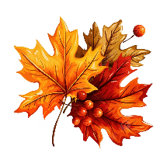Novembre

|  |  |  |
| --- | --- | --- |
| **V** | **1** |  |
| **S** | **2** |  |
| **D** | **3** |  |
| **L** | **4** |  |
| **M** | **5** |  |
| **M** | **6** |  |
| **J** | **7** |  |
| **V** | **8** |  |
| **S** | **9** |  |
| **D** | **10** | Départ du Vendée Globe 2024 **Départ Vendée Globe** |
| **L** | **11** |  |
| **M** | **12** |  |
| **M** | **13** |  |
| **J** | **14** |  |
| **V** | **15** |  |
| **S** | **16** |  |
| **D** | **17** |  |
| **L** | **18** |  |
| **M** | **19** |  |
| **M** | **20** |  |
| **J** | **21** |  |
| **V** | **22** |  |
| **S** | **23** |  |
| **D** | **24** |  |
| **L** | **25** |  |
| **M** | **26** |  |
| **M** | **27** |  |
| **J** | **28** |  |
| **V** | **29** |  |
| **S** | **30** |  |

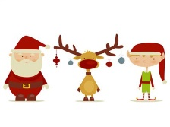DECembre

|  |  |  |
| --- | --- | --- |
| **D** | **1** |  |
| **L** | **2** |  |
| **M** | **3** |  |
| **M** | **4** |  |
| **J** | **5** |  |
| **V** | **6** |  |
| **S** | **7** |  |
| **D** | **8** |  |
| **L** | **9** |  |
| **M** | **10** |  |
| **M** | **11** |  |
| **J** | **12** |  |
| **V** | **13** |  |
| **S** | **14** |  |
| **D** | **15** |  |
| **L** | **16** |  |
| **M** | **17** |  |
| **M** | **18** |  |
| **J** | **19** |  |
| **V** | **20** |  |
| **S** | **21** | **HIVER** |
| **D** | **22** |  |
| **L** | **23** |  |
| **M** | **24** |  |
| **M** | **25** | Vecteur Noël Illustration Du Père Noël Clip Art Libres De Droits , Vecteurs  Et Illustration. Image 11463990. Joyeux Noel |
| **J** | **26** |  |
| **V** | **27** |  |
| **S** | **28** | Image associÃ©e |
| **D** | **29** |  |
| **L** | **30** |  |
| **M** | **31** |  |

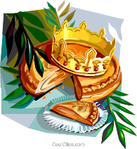Janvier

|  |  |  |
| --- | --- | --- |
| **M** | **1** | Bonne annEe |
| **J** | **2** |  |
| **V** | **3** |  |
| **S** | **4** |  |
| **D** | **5** |  |
| **L** | **6** |  |
| **M** | **7** |  |
| **M** | **8** |  |
| **J** | **9** |  |
| **V** | **10** |  |
| **S** | **11** | Image associÃ©e |
| **D** | **12** |  |
| **L** | **13** |  |
| **M** | **14** |  |
| **M** | **15** |  |
| **J** | **16** |  |
| **V** | **17** |  |
| **S** | **18** |  |
| **D** | **19** |  |
| **L** | **20** |  |
| **M** | **21** |  |
| **M** | **22** |  |
| **J** | **23** |  |
| **V** | **24** |  |
| **S** | **25** |  |
| **D** | **26** |  |
| **L** | **27** |  |
| **M** | **28** |  |
| **M** | **29** |  |
| **J** | **30** |  |
| **V** | **31** |  |

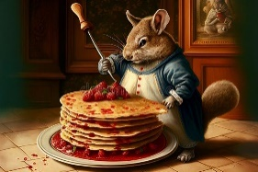 FEVRier

|  |  |  |
| --- | --- | --- |
| **S** | **1** |  |
| **D** | **2** |  |
| **L** | **3** |  |
| **M** | **4** |  |
| **M** | **5** |  |
| **J** | **6** |  |
| **V** | **7** |  |
| **S** | **8** |  |
| **D** | **9** |  |
| **L** | **10** | Image associÃ©e |
| **M** | **11** |  |
| **M** | **12** |  |
| **J** | **13** |  |
| **V** | **14** |  |
| **S** | **15** |  |
| **D** | **16** |  |
| **L** | **17** | Image associÃ©e |
| **M** | **18** |  |
| **M** | **19** |  |
| **J** | **20** |  |
| **V** | **21** |  |
| **S** | **22** |  |
| **D** | **23** |  |
| **L** | **24** |  |
| **M** | **25** |  |
| **M** | **26** |  |
| **J** | **27** |  |
| **V** | **28** |  |
|  |  |  |
|  |  |  |
|  |  |  |

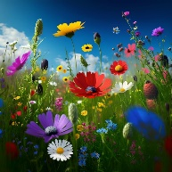Mars

|  |  |  |
| --- | --- | --- |
| **S** | **1** |  |
| **D** | **2** |  |
| **L** | **3** |  |
| **M** | **4** |  |
| **M** | **5** | Image associÃ©e |
| **J** | **6** |  |
| **V** | **7** |  |
| **S** | **8** | Image associÃ©e |
| **D** | **9** |  |
| **L** | **10** |  |
| **M** | **11** |  |
| **M** | **12** |  |
| **J** | **13** |  |
| **V** | **14** |  |
| **S** | **15** |  |
| **D** | **16** |  |
| **L** | **17** |  |
| **M** | **18** |  |
| **M** | **19** | Image associÃ©e |
| **J** | **20** | Image associÃ©e **PRINTEMPS** |
| **V** | **21** |  |
| **S** | **22** |  |
| **D** | **23** |  |
| **L** | **24** |  |
| **M** | **25** |  |
| **M** | **26** |  |
| **J** | **27** |  |
| **V** | **28** |  |
| **S** | **29** |  |
| **D** | **30** |  |
| **L** | **31** |  |

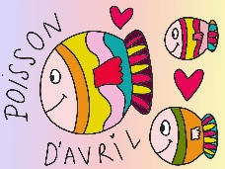Avril

|  |  |  |
| --- | --- | --- |
| **M** | **1** |  |
| **M** | **2** |  |
| **J** | **3** | RÃ©sultat de recherche d'images pour "dessin piscine" Piscine |
| **V** | **4** |  |
| **S** | **5** |  |
| **D** | **6** |  |
| **L** | **7** |  |
| **M** | **8** |  |
| **M** | **9** |  |
| **J** | **10** | RÃ©sultat de recherche d'images pour "dessin piscine" |
| **V** | **11** |  |
| **S** | **12** |  |
| **D** | **13** |  |
| **L** | **14** |  |
| **M** | **15** |  |
| **M** | **16** |  |
| **J** | **17** | RÃ©sultat de recherche d'images pour "dessin piscine" Image associÃ©e |
| **V** | **18** |  |
| **S** | **19** |  |
| **D** | **20** |  |
| **L** | **21** |  |
| **M** | **22** |  |
| **M** | **23** |  |
| **J** | **24** |  |
| **V** | **25** |  |
| **S** | **26** |  |
| **D** | **27** |  |
| **L** | **28** |  |
| **M** | **29** |  |
| **M** | **30** |  |

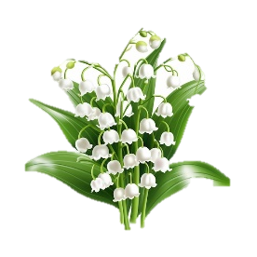Mai

|  |  |  |
| --- | --- | --- |
| **J** | **1** | Férié |
| **V** | **2** |  |
| **S** | **3** |  |
| **D** | **4** |  |
| **L** | **5** |  |
| **M** | **6** | Image associÃ©e |
| **M** | **7** |  |
| **J** | **8** | Férié |
| **V** | **9** |  |
| **S** | **10** |  |
| **D** | **11** |  |
| **L** | **12** |  |
| **M** | **13** |  |
| **M** | **14** |  |
| **J** | **15** | RÃ©sultat de recherche d'images pour "dessin piscine" |
| **V** | **16** |  |
| **S** | **17** |  |
| **D** | **18** |  |
| **L** | **19** |  |
| **M** | **20** |  |
| **M** | **21** |  |
| **J** | **22** | RÃ©sultat de recherche d'images pour "dessin piscine" |
| **V** | **23** |  |
| **S** | **24** |  |
| **D** | **25** |  |
| **L** | **26** |  |
| **M** | **27** |  |
| **M** | **28** |  |
| **J** | **29** | Férié |
| **V** | **30** | Férié |
| **S** | **31** |  |

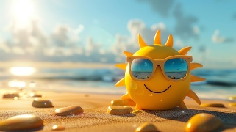Juin

|  |  |  |
| --- | --- | --- |
| **D** | **1** |  |
| **L** | **2** |  |
| **M** | **3** |  |
| **M** | **4** |  |
| **J** | **5** | RÃ©sultat de recherche d'images pour "dessin piscine" |
| **V** | **6** |  |
| **S** | **7** |  |
| **D** | **8** |  |
| **L** | **9** |  |
| **M** | **10** |  |
| **M** | **11** |  |
| **J** | **12** | RÃ©sultat de recherche d'images pour "dessin piscine" |
| **V** | **13** |  |
| **S** | **14** |  |
| **D** | **15** |  |
| **L** | **16** |  |
| **M** | **17** |  |
| **M** | **18** |  |
| **J** | **19** | RÃ©sultat de recherche d'images pour "dessin piscine" |
| **V** | **20** |  |
| **S** | **21** | **ÉTÉ** |
| **D** | **22** |  |
| **L** | **23** |  |
| **M** | **24** |  |
| **M** | **25** |  |
| **J** | **26** |  |
| **V** | **27** |  |
| **S** | **28** |  |
| **D** | **29** |  |
| **L** | **30** |  |

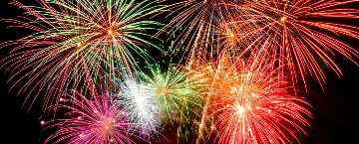Juillet

|  |  |  |
| --- | --- | --- |
| **M** | **1** |  |
| **M** | **2** |  |
| **J** | **3** |  |
| **V** | **4** |  |
| **S** | **5** |  |
| **D** | **6** |  |
| **L** | **7** |  |
| **M** | **8** |  |
| **M** | **9** |  |
| **J** | **10** |  |
| **V** | **11** |  |
| **S** | **12** |  |
| **D** | **13** |  |
| **L** | **14** |  |
| **M** | **15** |  |
| **M** | **16** |  |
| **J** | **17** | Image associÃ©e |
| **V** | **18** |  |
| **S** | **19** |  |
| **D** | **20** | Image associÃ©e |
| **L** | **21** |  |
| **M** | **22** |  |
| **M** | **23** |  |
| **J** | **24** |  |
| **V** | **25** |  |
| **S** | **26** |  |
| **D** | **27** |  |
| **L** | **28** |  |
| **M** | **29** |  |
| **M** | **30** |  |
| **J** | **31** |  |

AOUt

|  |  |  |
| --- | --- | --- |
| **J** | **1** |  |
| **V** | **2** | Image associÃ©e |
| **S** | **3** |  |
| **D** | **4** |  |
| **L** | **5** |  |
| **M** | **6** |  |
| **M** | **7** |  |
| **J** | **8** |  |
| **V** | **9** |  |
| **S** | **10** |  |
| **D** | **11** |  |
| **L** | **12** |  |
| **M** | **13** |  |
| **M** | **14** |  |
| **J** | **15** |  |
| **V** | **16** |  |
| **S** | **17** |  |
| **D** | **18** |  |
| **L** | **19** |  |
| **M** | **20** |  |
| **M** | **21** | Image associÃ©e |
| **J** | **22** |  |
| **V** | **23** |  |
| **S** | **24** |  |
| **D** | **25** |  |
| **L** | **26** |  |
| **M** | **27** |  |
| **M** | **28** |  |
| **J** | **29** |  |
| **V** | **30** | Image associÃ©e |
| **S** | **31** |  |