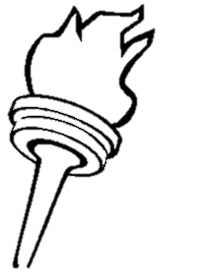
LEANDRE
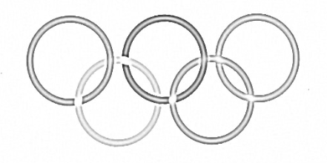
SARA

CELENE

MELLINA
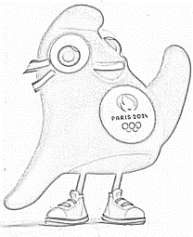
ETHAN
LUCIE
YASSAMBA
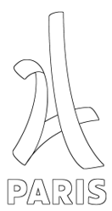
SOHAIB
LOU-ANNE
YANISS
SOHAN
EMMA
LUNA
NATHAN
SAMY
YSSAM

